**4.NODE RED CONNECTION:**

**LINK:** [**https://node-red-cdaue-2022-11-17.eu-de.mybluemix.net/red/#flow/40f9999a0fb0cc65**](https://node-red-cdaue-2022-11-17.eu-de.mybluemix.net/red/#flow/40f9999a0fb0cc65)

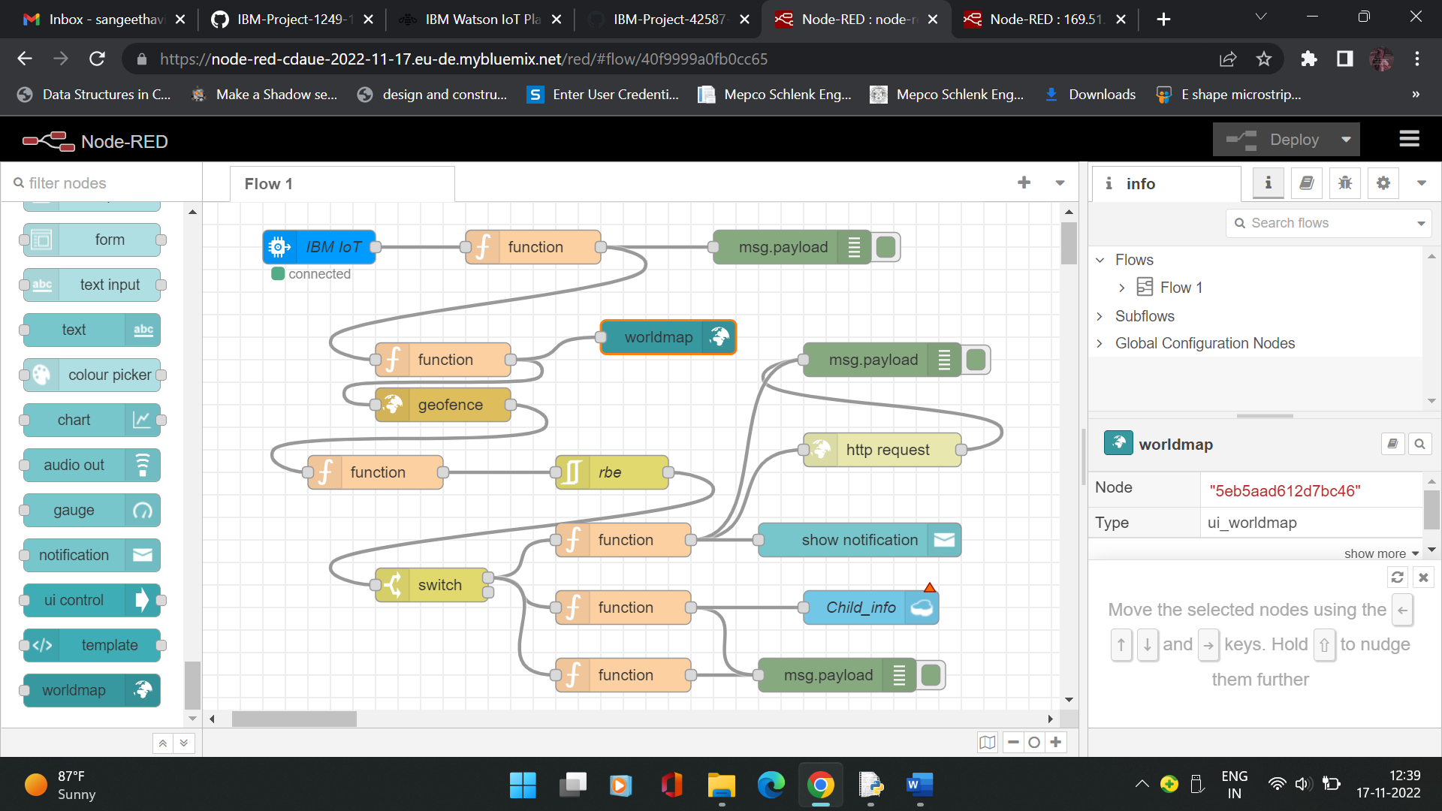

**Function1:Msg=”Person not in that area":**

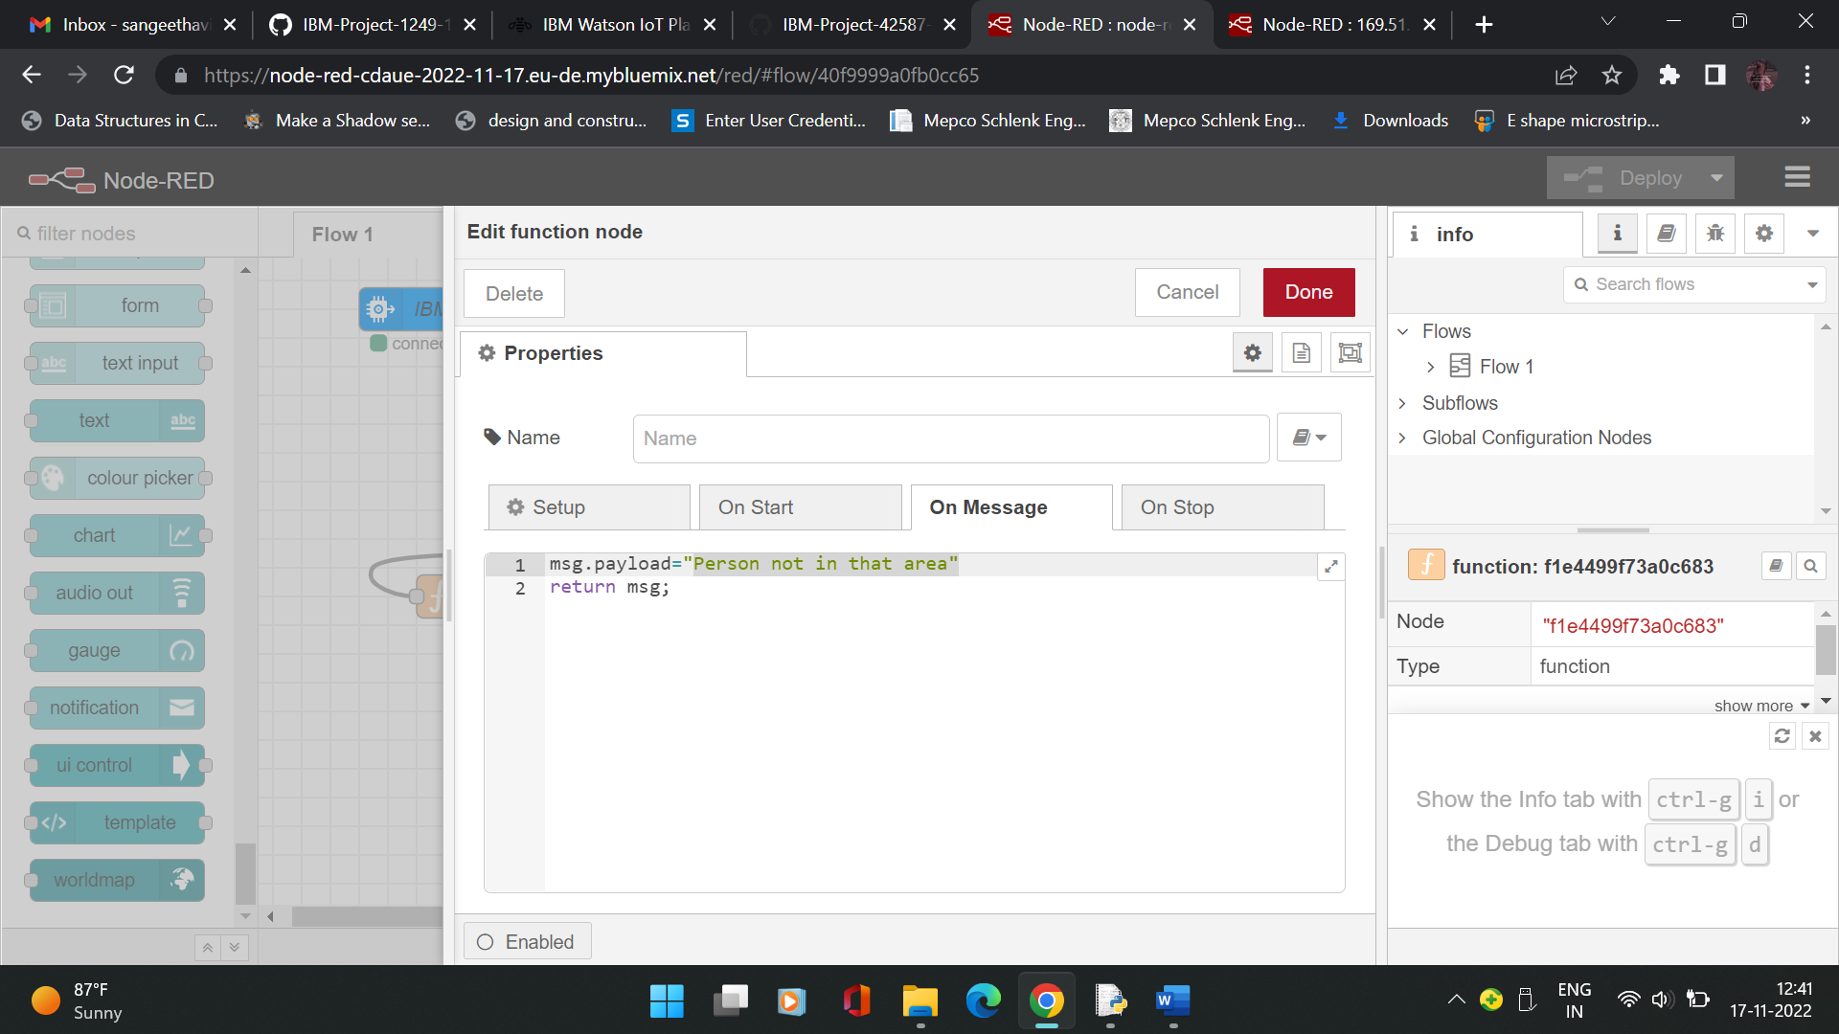

**Function 2:**

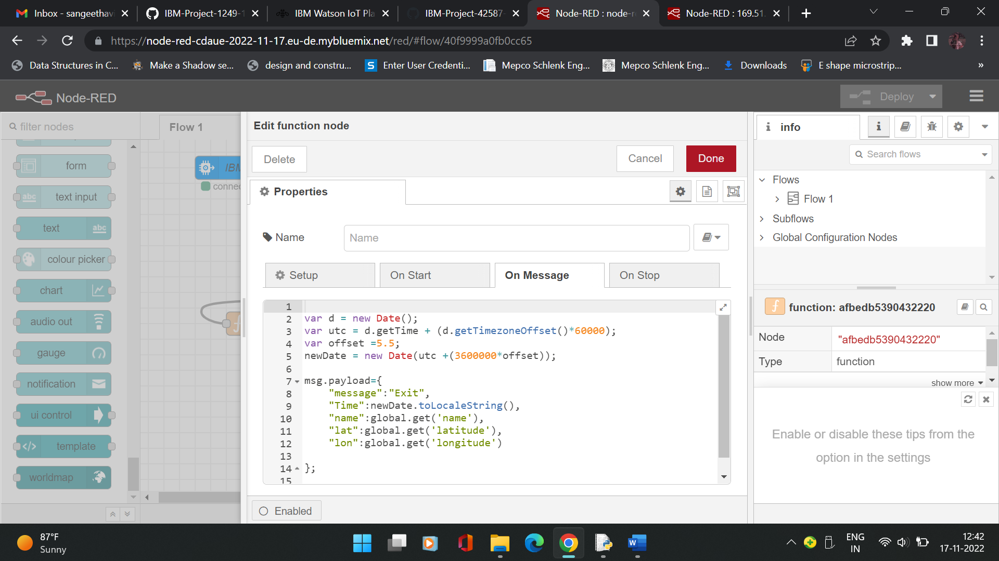

**Function 3:**

